**20.3.1**

My acting job is tonight, and I don't have a right clothes

What do you need to wear?

Marti want me to wear black clothes

Do you have black clothes?

No

It's OK. I give you some black clothes

Is this what Dona wear?

Yes, you look good

OK, I have to go now

Good luck!

Where are you?

My name is Shen, my agent is Marti Bloom

Oh year, you are here for the job

Yes

**I'm a very good actor**

OK, what's that?

**I'm wearing black clothes**, you want me to wear black top, right?

Yes, but that, whatever. **Tonight’s a big night**

I know. Where are the cameras?

Cameras?

Yes, the cameras to film us

OH, they are there, and there. Do you know to do tonight?

No, can you tell me?

Yeh, when people come to the door, you ask the names, you look at the list. If the name is on the list, they can go inside. If the name isn't on the list, they can't go inside

That's easy

Perfect! Now look at the names, there are five important people, You need to know they look like. I can described them to you

OK, important people. Are they actor?

There is one actor

Is it Dan Blaze

Yes, you come to dinner Dan Blaze

Yes

OK. There are four other people you need to know. The first is Uri Blovokov, **he's tall and skinny, he has one arm**

Uri Blovokov, tall, skinny, one arm

Yes, the second is Penelope Vega, **she's very pretty**, **she has long hair, big eyes**

Penelope Vega, long hair, and big eyes

Third person is Benedict Crumbswitch, **he's short and fat**

Benedict Crumbswitch, short and fat

Fouth person is Shen Li

I am Shen Li

No, I'm sorry, not you

His name is Li Shen, **he's big and strong**, he...

Agent?

Yes, Li Shen, big, strong and agent

Do you good job tonight or…

**Practice**

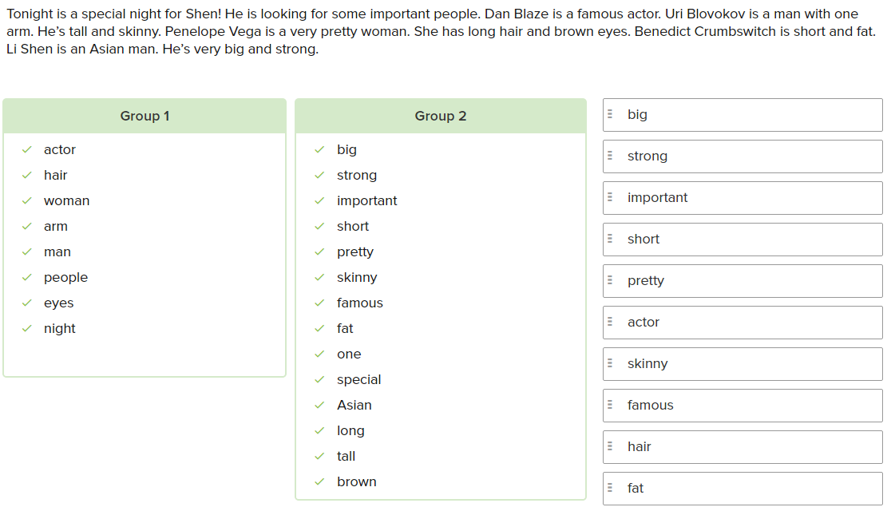

**Conversation**

And here it’s a great photo’s my brother. I love this picture. The weather…perfect, do you think?

Perfect? No, it isn’t perfect! It’s windy and rainy and too really awful!

I know! And look at this clothes. Do you think he warm?

No, I sure he’s really cold. That suit isn’t good for this terrible weather!

Hey, Do you have any photo of your little brother are they?

Yes, this one is nice! It’s a photo of Alex and his five good friends!

Woa! Which one is he? He isn’t a little boy anymore. Is he boy in a light T-shirt?

That’s him in the front. He’s wearing green T-shirt

Woa, I can see he’s not shot and fat anymore

No he’s not! He was short and fat when he was ten years old. But now he’s tall and skinny!

What’s about the boy in a red short on the left? I think I know him

The one with short brown hair? That’s Bobby. I like him a lot. He’s funny and nice, and really kind

**Exercise**

The man’s sister has strong arms and legs

She was short

Ed has a big day, and she’s excited

How does Ed feel?

-> Happy

Why does the man want to stay home?

-> He’s tired

Why doesn’t the man want to call the Italian restaurant?

-> It’s isn’t open on Monday nights

How many man are they taking about?

-> 3

**Repeat**

Why do I need to wear it?

You need to wear it, so can hear me when I talk

When do you want me to wear it?

When can I take it off?

When we close

Why it isn’t working?

When do we start?

Right now

**Practice**

James, when can I go home?

Sarah, why aren’t the phones working?

Louis, what do we need to buy at the supermarket?

David, how do I turn it off?

Annie, when do you want me to open the restaurant?

Mitch, why don’t you want to go shopping tomorrow?

Ellen, how are you getting to work today?

Joe, where do I need to go with the boss tonight?

**Skills Practice**

When can I go home?

-> When we close the restaurant

Something’s wrong with my computer. Why isn’t it working?

-> You need to turn it on

I have an idea for a new product. What do I need to do next?

-> Call the boss and tell him about it

Where do you want me to stand?

-> Over there, next to the door.

How do I get home form here?

-> Take the Number Two bus to Barton Street

When can you open the restaurant tomorrow?

-> I can be there at 8:00 a.m. Is that OK?

How do you get to work in the morning?

I walk or take the subway

**Conversation**

Hi Emily, I know you was sick last week. It’s good to see you. How are you feeling?

I fine now. Thanks

Good, The boss is on the business trip this week, and he said we need to have a meeting every day

Every day? Why do we need to have a meeting every day?

Because the boss said he want a idea for a new product. And he want it on Monday

OK, so first we need to talk to the product designers. When can we have a meeting with them?

We can meet with them after lunch at 2 o’clock, but we can’t use the boss’s office

Why can’t we use the boss’s office?

Because he’s not here, and he doesn’t want anyone in his office

OK, so where do you want to have a meeting?

Project designer have a big office. We can have a meeting there

Good idea! I can call them right now

**Exercise**

What do I need to bring to the meeting?

-> Just a pen and some paper

I’m late! Where are we having the meeting?

-> In Jane’s office

Why aren’t you watching TV?

-> Because it’s broken

How do you like your new job?

-> I hate it

When are you working late this week?

-> On Tuesday and Friday

When can I go home?

-> When you finish your work

Why do I need to call the boss?

-> he wants to talk to you about the project

Why do you want to take my cell phone?

-> So I can call you when I need you

20.3.3

Excuse me, can I go inside?

What’s your name?

Shendy Jose

No

Hello, can I go inside?

(Talk, skinny, one arm)

Are you OK?

I’m OK. What your name?

Uri Blovokov

Where do you from?

**I’m from Russia**

**So you’re Russian**

Yes

Cool, **do you speak Russian**

Yes

**I speak English and Chinese**

Can I go in?

Oh, yes, you can

Uri Blovokov is here

Excuse me

Hello

Let’s me in

(Long hair, and big eyes)

What’s wrong with you?

Nothing. Are you Penelope Vega?

What do you think?

**I think you are Spanish**

**Yes, I’m form Spain**

**Can you speak Spanish?**

Yes, I speak English and Spanish

Can you teach me Spanish? I know English and Chinese

I can teach you Spanish now. Can I on my way? I’m going in

Penelope Vega is here

I want to dance in this club

(Short and fat)

What?

Is Benedict Crumbswitch?

I am

**Are you from England?**

**Yes, of course. I’m British**

Benny’s British

I don’t know Benny. Now I can go inside, please?

Sorry….Li Shen. I’m Shen Li. **We are Chinese**, **we can speak Chinese.** Where in China are you form? Where are you Dan Blaze?

No Dan Blaze tonight

No

My be next weekend. See you later, Shen

Shen is talking to people outside the club because he needs to see if their names are on his list

Shen asks Penelope Vaga to teach him to speak Spanish

One important person on Shen’s list does NOT speak to him. Who is it?

-> The man from Shen’s country

One important person on Shen’s list does NOT come to the club. Who is it?

-> Dan Blaze

**Practise**

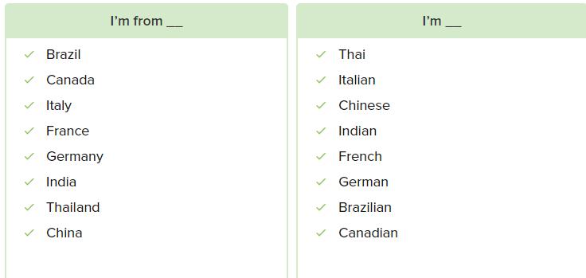

Skill Practise

Gisela comes from Germany, but she lives in the United States now. She teaches German to American students

Dana is American, but she was in Canada last June. Montreal and Toronto are her favorite Canadian cities

Khae’s family lives in Thailand. Her parents don’t speak English, so she writes them letters in Thai

Ed is from the United kingdom, but he is working in China this year. He’s British, and he only knows a few words in Chinese

Jacques has a French name, but he isn’t from France. He’s from Montreal in Canada

Luigi is from Rome, Italy. His first language is Italian, but he visit Spain a lot so his Spanish is excellent

My friend Raj is Indian. He speaks Hindi with his parents, but with me he speaks English. He want to visit India this year

Ivan is Russian, but he lives in England. He and his British wife have plans to visit Russia

**Conversation**

How are your acting job last night?

It’s wasn’t an acting job. I was a temp door man! It was awful!

OK, so are a door man. A door man look for important people, when important people at the club

Yes were four important people at the club

Tell me about them. Who is first?

Uri Blovolov was Russian He’s form Russia, and he speaks Russian

Cool! Who is next?

Penelope Vega. She’s very pretty! She’s from Spain, and she speaks two languages: Spainish and English

So, where are any people at the club from France or Germany?

No, there weren’t any France or Germany people, but Benedict Crumbswitch were there. He’s short and fat, and he’s from England. You and he are British

OK, that’s three people, who was four?

Li Shen. He’s from China, and he speaks Chinese

Woa, Were you friend in China?

No, we weren’t friends in China… and we’re not friends here in United States

**Exercise**

My friend Marta studies languages. She speaks German, Italian and Chinese

Consuela is Spanish, but her husband isn’t. he’s form Brazil

I have friends form India, Russia, and Spain

Gavin is from the United kingdom, but Joe isn’t. He’s French

Many people from Canada speak two languages: French and English

Juan is Spanish, but he works in New York City. His company is American

Maria is from Italy, but her roommate isn’t. She’s French

Sang loves London. It’s his favorites city in England

**Lesson Exercise**

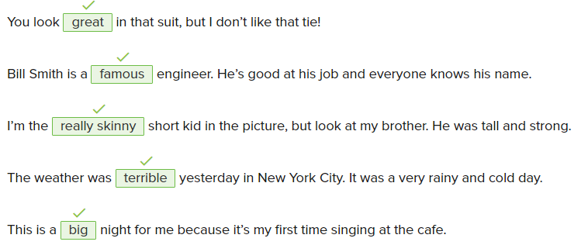

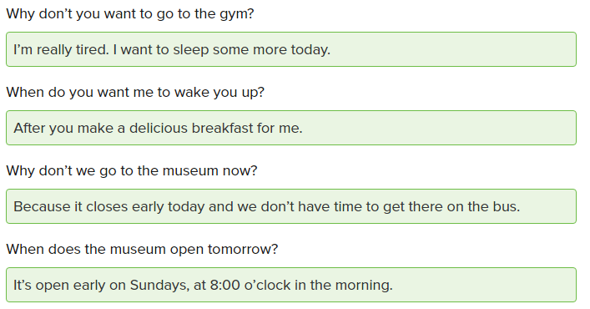

Where is the new employee in our American office from?

-> Oh, that’s Fritz. He’s from Germany, but his English is excellent

Where are you going for your business trip this week?

-> I’m going to Montreal. It’s in Canada. They speak French and English there

It’s fun to hear your roommates from around the world talk

-> Yes, they speak Italian, French, and Thai

We eat Asian food every night. Can we try something new?

-> Okay. Let’s go to that cheap French restaurant downtown. I don’t have a lot of money in my wallet

I’m from the United States and I speak English

But I go on work trips to Thailand sometimes and I can speak some Thai when I’m there. I’m not very good at it, but I try

Guiseppe is an Italian name, but I come from the United States

Now, I am studying German for my trip to Germany

My family is Russian, but they travel to London to see me

I’m from China, but I live in Montreal in Canada

I speak French when I’m at home in Quebec, but my parents speak Chinese

I know a lot of British people

Last year I was in Spain, France, and Germany

2/8

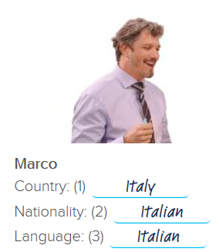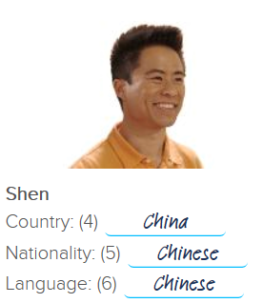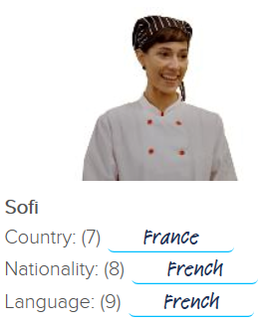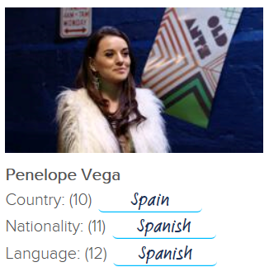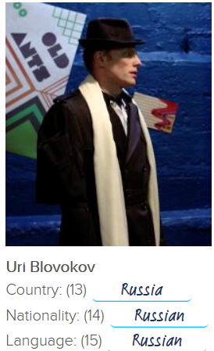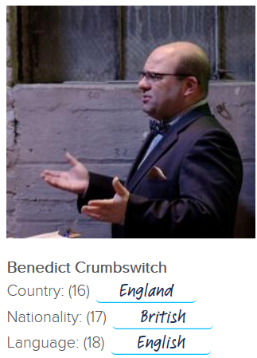

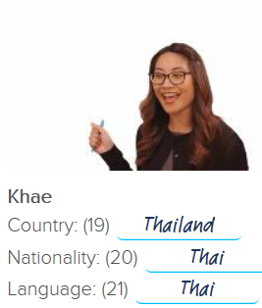

3/8

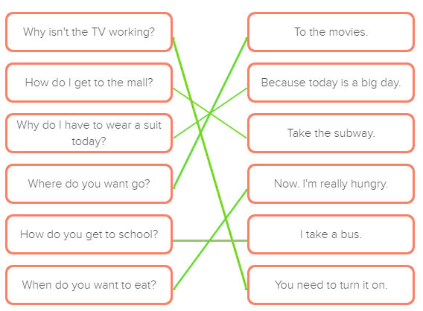

4/8

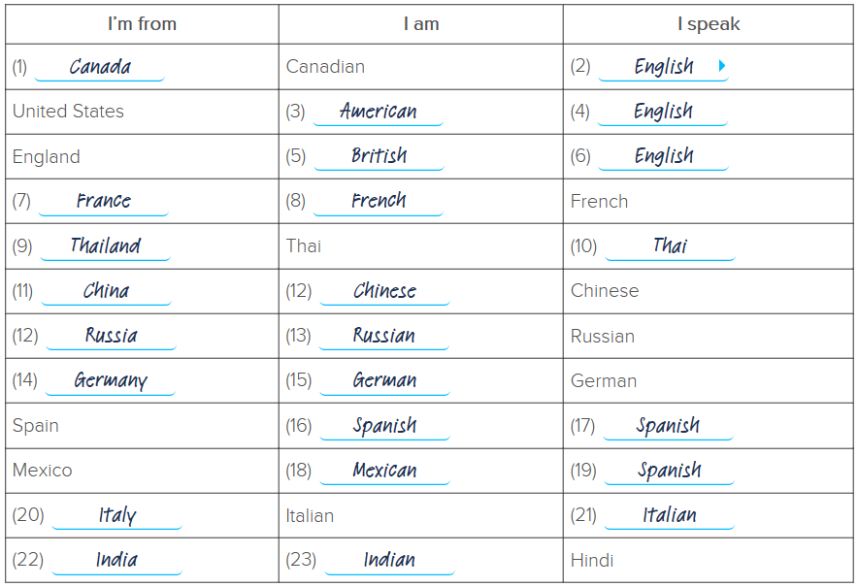

5/8



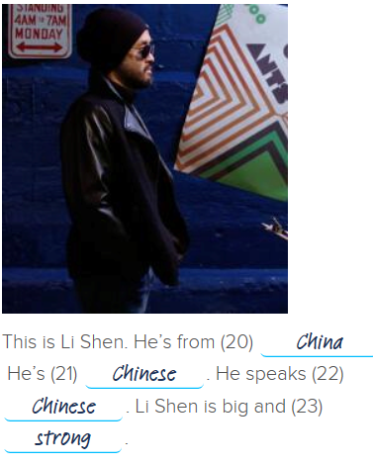

6/8

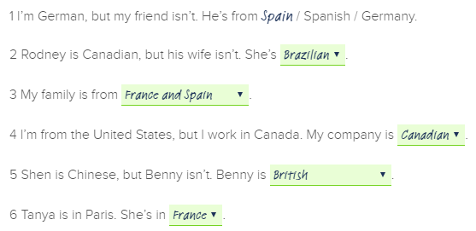

7/8

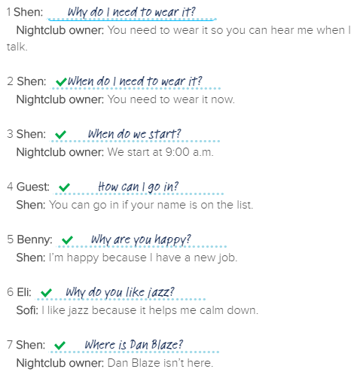

8/8

My name is Patricia Jones. I’m 26 years old. I live in Canada. I’m a teacher. I’m a

good teacher. I like my job because I like working with children. Every day I got to

work at 7 a.m. I take a subway to work. I come home at 5 p.m. In my free time, I like reading and watching TV.

1 What’s Patricia’s nationality?

She’s Canadian.

2 How old is she?

She’s 26.

3 What is her job?

She’s a teacher.

4 Why does she like her job?

She likes working with children.

5 What time does she go to work?

She goes to work at 7 a.m.

6 How does she go to work?

She takes the subway.

7 What time does he come home from work?

She comes home at 5 p.m.

8 What does she do when she doesn’t work?

She likes reading and watching TV.

9 Describe Patricia Jones. Look at her picture. Write three sentences.

Patricia is tall and skinny. She has long hair and big eyes. She is pretty.